電通二乙微處理器實驗 實驗結報

實驗名稱 | Lab11-MCS Cloud
組別 | 33 | 組員 | 簡佑霖

- 實驗目的
1.從雲端控制板子內建的LED
2.將7697測量到的電阻值上傳
- 實驗步驟

- 程式碼
- 雲端控制LED
#include <LWiFi.h>
#include "MCS.h"

char _lwifi_ssid[] = "AA201-2G";
char _lwifi_pass[] = "iteaa201";
MCSDevice mcs("DAeVb991", "R87fr7RZmZ0IGAth");

MCSControllerOnOff LED_control("led");
MCSDisplayOnOff LED("remote");

void setup()
{
Serial.begin(9600);

Serial.println("Connect to Wifi");
while (WiFi.begin(_lwifi_ssid, _lwifi_pass) != WL_CONNECTED) {
Serial.println("Wifi Reconnecting..");
delay(1000);
}
mcs.addChannel(LED_control);
mcs.addChannel(LED);
Serial.println("Connect to MCS...");

while (!mcs.connected()) {
Serial.println("MCS Reconnecting..");
mcs.connect();
}
Serial.println("MCS Connected!");

pinMode(7, OUTPUT);

}

void loop()
{
while (!mcs.connected()) {
mcs.connect();
if (mcs.connected()) {
Serial.println("MCS Reconnect");
}
}
while(!LED_control.valid())
{
Serial.println("read LED value from MCS...");
LED_control.value(); //取得MCS數值
}
Serial.print("done, LED value = ");
Serial.println(LED_control.value());

mcs.process(1000);

if (LED_control.value() == 1) {
digitalWrite(7, HIGH);

} else {
digitalWrite(7, LOW);

}
if(!LED.set(LED_control.value()))
{
Serial.print("Failed to update remote");
Serial.println(LED.value());
}

delay(200);
}
2.上傳電阻值
#include <LWiFi.h>
#include "MCS.h"

char _lwifi_ssid[] = "AA201-2G";
char _lwifi_pass[] = "iteaa201";
MCSDevice mcs("DAeVb991", "R87fr7RZmZ0IGAth");
MCSDisplayInteger Temp("Temp");

void setup()
{
Serial.begin(9600);

Serial.println("Connect to Wifi");
while (WiFi.begin(_lwifi_ssid, _lwifi_pass) != WL_CONNECTED) {
Serial.println("Wifi Reconnecting..");
delay(1000);
}
Serial.println("Connect to MCS...");
while (!mcs.connected()) {
Serial.println("MCS Reconnecting..");
mcs.connect();
}
Serial.println("MCS Connected!");

mcs.addChannel(Temp);
}
void loop()
{
while (!mcs.connected()) {
mcs.connect();
if (mcs.connected()) {
Serial.println("MCS Reconnect");
}
}
mcs.process(1000);

int sensor = analogRead(15);

Temp.set(sensor);
Serial.println("Add sensor value.");
delay(200);
}
- 實驗結果及分析
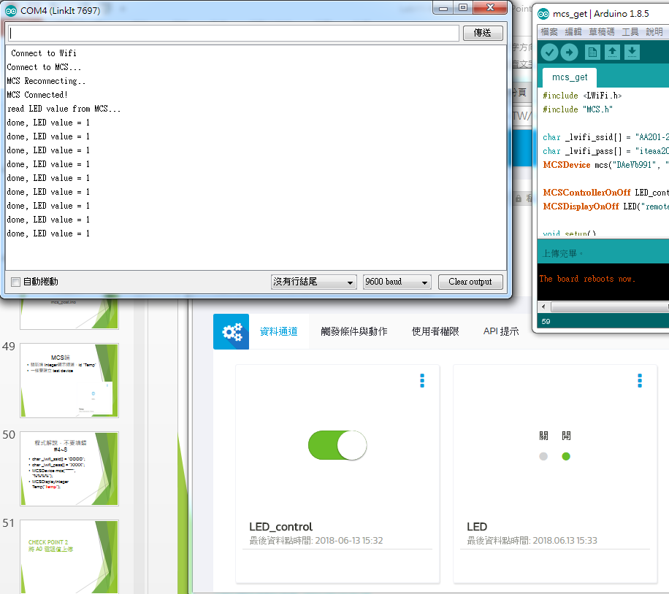
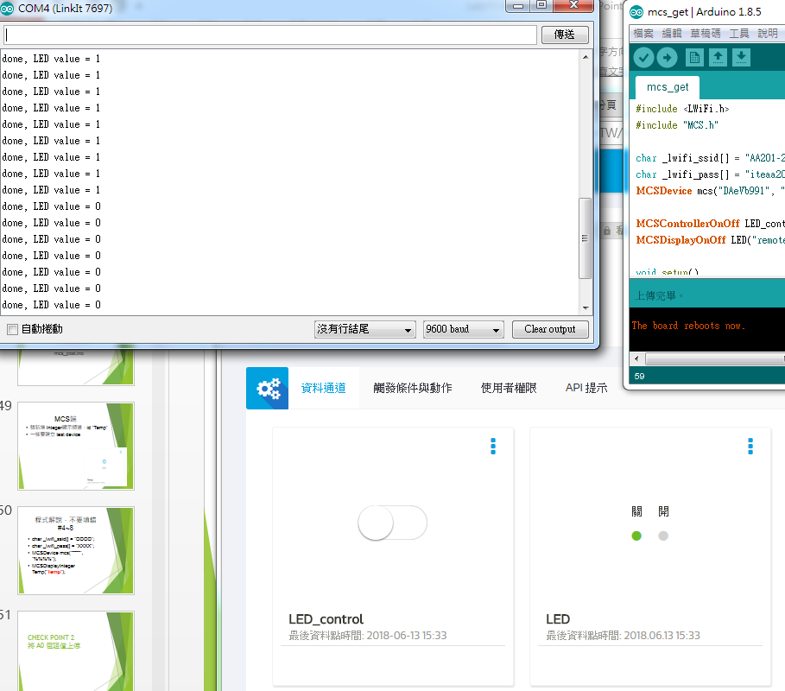
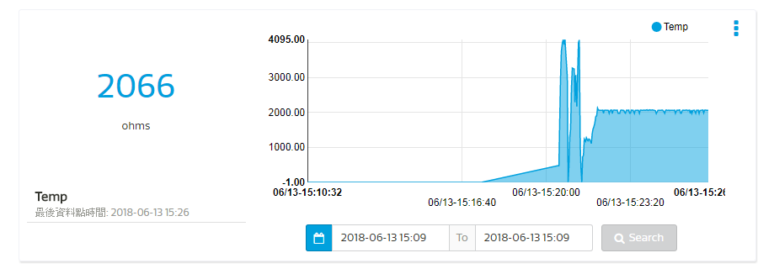
- 心得討論
成功完成簡易的遠端LED控制的物連網應用

